Biological Variability

I. INTRODUCTION

Variability is characteristic of biology. There is a great deal of variation between the species of plants, animals, and bacteria that inhabit the earth, and there is also considerable variation between individuals of a single species (Just look at others around campus for verification!). This latter type of variation makes the task of defining and characterizing species difficult, and this is confounded by the fact that individuals of one species often possess traits that overlap with those of another species. Because variation is inherent to all levels of biological organization, life scientists often must rely on statistical techniques when faced with tasks of classifying and making quantitative judgments. In the next two exercises. You will learn how to measure and quantify biological variation and get an introduction to using statistics in the analysis of variation.

You will design your own variability lab activity. Please, think about questions related to comparing two groups by measuring two parameters that can be statistically tested (differences in their variances and their means). Develop your hypothesis, design your methodology (how to gather the data), describe your results, and statistically analyze your data. Finally, analyze and discuss your findings. Please, make sure to include your references with the proper citation. You must also answer the sections of Data Analysis and Follow-Up Questions but applied to your own lab activity.

The following information from Epstein and Smith, is an example of how you perform your own variation experiment. Please, note that first, they describe the population in the introduction. Then, they show the methodology used in their experiment and how they measured their specimens. Please, go to Canvas, to Appendix G, if you want to see a reference lab report of this lab activity.

The Coquina clam
The organism that we will use for this exercise is commonly known as the Coquina clam (scientific name: Donax sp.}. This is a small bivalve clam (meaning that it has two shells connected by a single hinge) that is found in sandy exposed beaches throughout the world and is common in the Eastern United States and the Gulf of Mexico. It lives in the upper 4 cm or so of sand between the high and low tide marks, and more than 20,000 individuals/m² can be found in favorable locations. They are a source of endless fascination for the younger visitors to Florida's beaches and are known to make an excellent stock for seafood chowder.

Coquina clams are extremely variable in appearance. As exemplified by the diverse populations of clams that inhabit the local beaches of the Gulf Coast, individuals with a wide range of shell colors, sizes, and textures are often found in the same territory. This variability has led to considerable confusion and debate among biologists about the classification of the Donax species. Some biologists believe that all of the Coquina clams that inhabit the Florida coasts are members of a single species, Donax variabilis, and that the different shell morphologies are a reflection of natural variation within a single species. Other researchers contend that there are at least two species that occur sympatrically (in the same locality) on Florida's beaches: Donax variabilis and Donax parvula. These species are similar, but there are some differences in their average shell shape and size, with D. parvula being smaller in terms of width and length. However, the overall size ranges of the two species overlap significantly, and it is not possible to classify individual clams by size alone. A more definitive criterion for distinguishing these two species has also been proposed. Specifically, the angle between the anterior and posterior dorsal shell margins (see diagrams p. 40) is 120.9° for D. parvula and 131.4° for D. variabilis. To further complicate matters, a third species, D. dorotheae, has been proposed to inhabit the beaches of northern Florida, but the shell angle of this species was not reported.
Shells from dead Coquina clams have been collected for you from Cape San Bias, a northern Gulf coast beach. You will use the criterion of shell angle to classify these shells, and will then measure certain features of the shells and use these measurements in a statistical comparison of the populations. The purpose of the exercise is to illustrate biological variability and how biologists make judgments concerning the significance of observed similarities and differences between populations. Unfortunately, your findings will not help to resolve the species problem, but you will learn some of the tools that are required to do so.

II. OBJECTIVES
- To understand variability that occurs within and between species.
- To make a series of precise biological measurements.
- To learn basic descriptive statistics, specifically mean, cumulative mean, variance, and standard deviation of a sample.
- To learn basic inferential statistics, specifically the Student's t-test and F-test.
- To use Excel™ or a spreadsheet software to perform the t-test and the F-test, and to generate a data distribution curve.

III. MATERIALS
- Coquina clam shells from the northern Gulf coast (Cape San Bias)
- caliper
- overhead transparency projector and screen
- 120.9'and 131.4° angle templates
- calculator
- Computer

IV. METHODOLOGY

A. Introduction
Each lab will be split into 6 groups of 4 students. Although most groups will work with shells collected from Cape San Bias, shells from other Florida locations may be available and assigned to some of the groups. Each group will sort through their assigned shells until they find 35 that have a 120.9° angle between their anterior and posterior margins, and another 35 that have a 131.4" angle.

B. Procedure
- To measure the shell angles, put the shells on a transparency projector placed about 5 feet from the screen and use the angle templates to measure the angle of the projected shadow. See Fig. 1 for some examples to help you measure the angles. Do not agonize over this measurement for every shell. If you can't classify a shell to your satisfaction, ignore that shell and go on to another. Some shells may have angles that are clearly smaller (or larger) than the angles we are examining. You may wish to save these shells and classify them as representatives of a third population.
- Discard any shells that are chipped or broken.
- Finally, it is good practice to have a second student check every angle assignment after the initial classification.
- While some members of your group continue to collect the required number of shells with each angle, the other members can start measuring the length, width, and height of the shells already collected. The TA will show you how to use a caliper, and Fig. 2 includes some pointers for making these measurements. Switch duties occasionally so that each member of the group gets experience measuring angles and measuring the other shell dimensions.
- As you make these measurements, record the data on the table provided in the worksheet. Make sure that all members of your group get a complete record of all shell measurements.

C. Descriptive Statistics
Calculation of the sample mean (x)
A commonly used descriptive statistic for describing a biological variable is the mean. This represents the average of all measurements made of the variable, and is calculated by adding the individual measurements and dividing by the total number of measurements:

Mean (x) = Σx_{i} / N
(x)
= mean

Σ = to sum
_{Xi} = each individual measurement

N = total number of measurement
• Calculate the mean for the shell length for populations 1 and 2 and record your means in the worksheet at the end of the lab.

Cumulative means and determining adequate sample sizes
In order to make valid inferences about a population from statistical calculations of a sample of that population, the sample must be a fair and accurate representation of the population. This means that the sample must not be biased in any way, but it also means that the sample must be large enough to fairly represent all members of the population being sampled. On the other hand, a sample that is larger than necessary merely compounds the work of the observer without significantly improving the accuracy of the sampling. One method to determine the appropriate sample size for a given population is to calculate a series of cumulative means (x_{c}) as the data is being collected. This is done by calculating a new mean, which includes all previous measurements, after each new measurement is added to the data. At first, the values of the cumulative mean fluctuate as each new measurement is made. At some point during the sampling process, however, additional measurements do not significantly affect the value of the cumulative mean, i.e., it becomes stable. The number of measurements that are required to obtain a cumulative mean of some desired stability determines the minimum sample size. The more variable the data, the larger the number of measurements required to obtain a stable mean.
• For the length measurements of the shells with 120.9° angles, calculate the cumulative means after each additional measurement. Record these in the space provided in the table in the worksheet.
Variance (s²)
The mean value for a variable tells you the average value for that variable in the population, but it does not indicate to what extent individuals in that population vary from that mean. A more complete description of a variable includes the mean of that characteristic as well as some index of its variability. One of the ways of expressing variation is called variance, which is a measure of the average deviation from the mean of all the individual measurements. The formula for computing the variance is as:

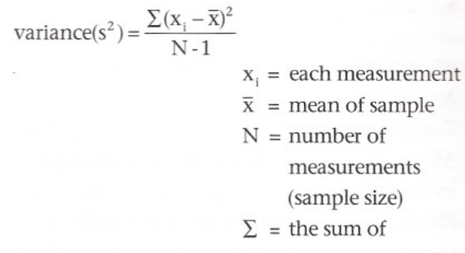
• Because of the complexity of this calculation, you could use a computer to determine the variances for each of the variables you measured. However, to ensure that you understand the calculation, compute the variance for the length of the first ten shells in the sample of shells with 120.9° angles. For this calculation, use the cumulative mean you calculated above at the tenth measurement for x, and use a sample size (N) of 10.
Standard Deviation (s)
Standard deviation is another measure of variation that is used in many statistical calculations. It is calculated by taking the square root of the
variance:
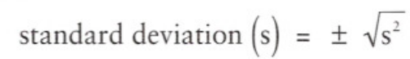

• Using the variance you calculated for the first ten 120.9° shells, calculate the standard deviation.
D. Clean-up Procedures
• Return calipers and angle templates to the counter for the next section.
• Pick up all shells from the lab bench and floor and return them to the plastic bag.
Fig. 1: Examples of measurements of the angle between the anterior and posterior dorsal shell margins on actual tracings of projected shell images.
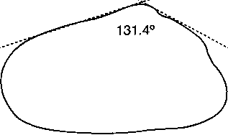
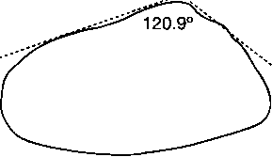
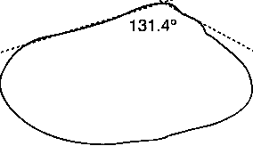
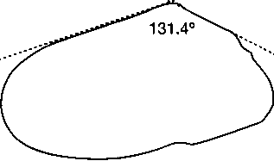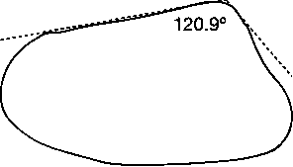
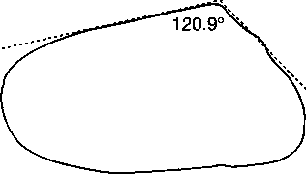

anterior
Angle between anterior and posterior dorsal shell angles

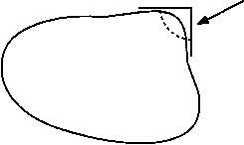
dorsal
posterior
ventral

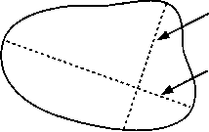

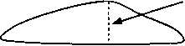
height
width-- goes through hinge region and lies perpendicular to length

length-- greatest distance between anterior and posterior shell margins

side view of shell

Fig. 2: Terminology for measuring Coquina shells, (see Chapter 33 of your textbook for the internal anatomy of clams)

DATA ANALYSIS AND FOLLOW-UP QUESTIONS
Record the dimensions (in mm) measured for each shell in the following table. Leave the cumulative mean column blank for the time being.

 | Sample 1 Shells with 120.9° angles |  |  |  |  | Sample 2 Shells with 131.4° angles
Shell number | L (mm) | Cumulative mean (mm) | W (mm) | H (mm) |  | L (mm) | W (mm) | H (mm)
1

2

3

4

5

6

7

8

9

10

11

12

13

14

15

16

17

18

19

20

21

22

23

24

25

26

27

28

29

30

31

32

33

34

35

You could use a computer to determine some basic descriptive statistics of the sample measurements you have recorded. To fully understand what the computer is doing you must understand the parameters that are being calculated and the formulas used in the calculations.
Populations and Samples
Question 1.
Each set of 35 shells with similar shell angles represents a sample of a larger population. The shells that were used in this exercise were collected as dead specimens (we did not feel that this laboratory exercise warranted mass killings of the Florida Coquina populations). What are some potential problems in trying to compare your results with the results of studies in which living Coquina populations were sampled? In other words, for what reasons are empty shells on the beach not necessarily representative of the living population in the immediate vicinity?

(x)

Calculation of the sample mean
Question 2.
Calculate the mean length for the samples (in the example, the shells) in each of your two samples.

(x)
length for sample of population 1 _________________________
(x)
length for sample of population 2 _________________________

Question 3.
It is extremely unlikely that the two means you just recorded are identical. Can you conclude that there are differences between the two populations based only on these mean values? Explain why or why not.

Computer Aided Analysis of Coquina Shell Measurements

IV. EXERCISE

Inferential statistics
The goal of this exercise is to determine if there are differences between your samples other than the difference that was initially used to classify the shells (the angle between the anterior and posterior dorsal shell margin). We will use the

Student's t-test to test the null hypothesis that "there are no differences in the lengths, widths, and heights of the two samples." To properly use the t-Test, we must first determine if the variances you calculated for the two samples are equal. We will therefore start with an F-test to test the hypothesis that "the variances in the length measurements are the same for the two samples."
The lab report should include a Data Distribution Curve, the Student’s t-test, the F-test, and descriptive statistics.
DATA ANALYSIS AND FOLLOW-UP QUESTIONS
Question 1.
The t-tests you performed are valid only if the populations being compared have normal distributions and similar internal variation for the parameters being measured. What was the p-value for the F-test that you performed? Does this indicate that the data meets or does not meet the assumption of equal variances?

Question 2.
Describe the outcome of the statistical analyses (t-tests) of your data for length, width, and height. In each case, what were the p-values and what are your conclusions about the populations being compared?

Question 3.
Do your results agree with the information from your Introduction and the literature reviewed related to your questions? Explain your answer and your results.

Question 4.
This exercise probably generated more questions than answers. State a question or unusual observation that came up while you were performing this exercise. Propose a simple hypothesis to answer this question or explain the observation. How would you test this hypothesis? Make the hypothesis and experimental test of the hypothesis as simple as possible.

, 2This labs has been extracted from: Epstein and R. Smith. 2006 Biological Science I, BSC 2010L Laboratory Manual. 2005-2006. Florida State University, Department of Biological Sciences. Tallahassee, Florida. Hayden-McNeil Publishing Inc. eds.
Morrison, /. P. E., 7 977. Western Atlantic Donax. Proceedings of the Biological Society of Washington 83: 545-568.
Nelson, W. G., E. Bonsdorff, and L. Adamkewicz, 7 993. Ecological, Morphological, and Genetic Differences Between the Sympatric Bivalves Donax variabilis Say, 1822, and Donax parvula Philippi, 1849. The Veliger 36:317-322.

